**USE CASE DIAGRAM FOR LIBARAY MANAGEMENT SYSTEM:**

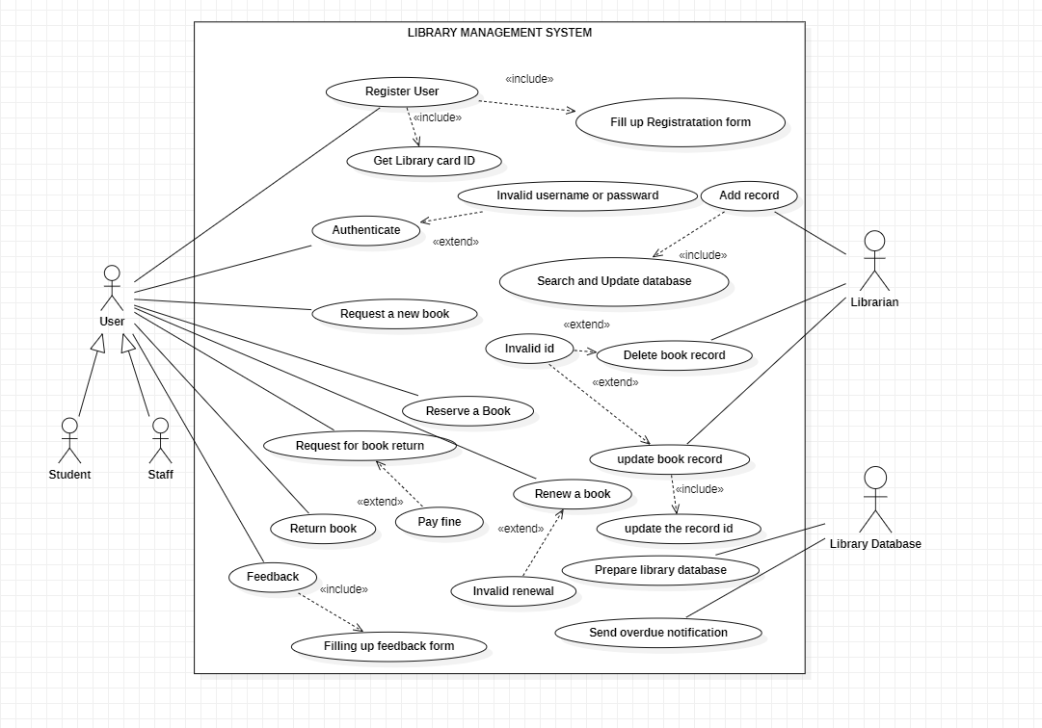

**USE CASE DIAGRAM FOR DATABASE:**

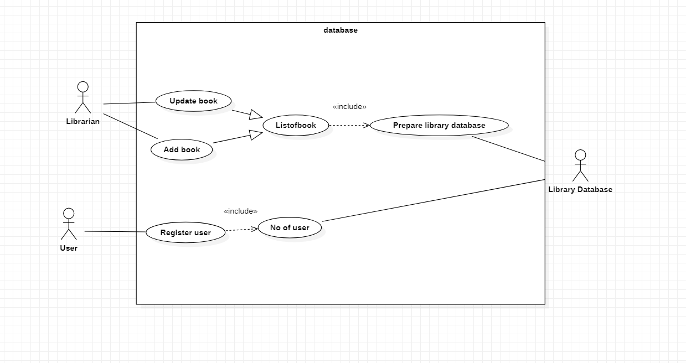

**USE CASE DIAGRAM FOR REGISTER USER:**